**Lab 3: BJT as a current source: Emitter Follower   
 [80 + 20 advanced]  
Prerequisite:**You must have a working simulation and physical implementation of a waveform **F**unction **G**enerator that swings to both positive and negative voltages, as worked out in Lab 1 + 2. We call this the FG for short throughout the rest of this lab.   
The official standardized design is published on moodle – use those component values to get a reliable output and test that your FG works as expected.   
Settings for LTSpice: Use the following timing parameters in LTSpice simulation command

Stop time = 101m

Time to start saving data = 100m

Maximum time step = 0.01m

This skips the initial transients in the first 10ms of simulation caused by calculation artefacts, capacitive charging etc and gives you a stable picture of one full cycle of Vin @ *f~ 1kHz*

**Grand goal:**   
Design a BJT based circuit that has no voltage gain, but is able to amplify a small input current to a large output current. In terms of impedance, it means that the final circuit design must have very high input impedance and very low output impedance. This is very attractive for practical applications, since most electro-mechanical devices are driven by current.   
Note about terminology of ‘current’ used in this assignment:

1. We consider the traditional Kirchoff’s Law current *I* in the circuit design and analysis. This current can be flowing in either direction across two nodes in a circuit. Though as explained in the introduction session, inside an NPN/PNP transistor, the current *I* flows exclusively from the Collector to the Emitter.
2. The term AC current used here refers to a time-varying current, and is denoted in small case *i*.    
   In contrast, a DC current denoted by capital letter *I* is one whose value remains constant with time.  
   Generalizing, a DC voltage is one which is constant in time (like the 9V supply to your circuit), and an AC voltage is one which varies as a function of time, like the output of your FG.
3. If Vout is supplying current to the load, we say the circuit is ‘sourcing current’. Vice-versa, if current is being pulled *into* the circuit from the load, we say the circuit is ‘sinking current’

**Part (A) Circuit Design**

Fig 1 shows the basic structure of a current amplifier circuit . In principle, since *IC = βIB* this is all you need to crack this lab assignment! or… is it?

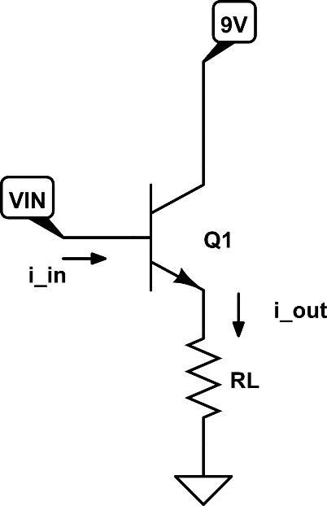

Fig 1:   
The BJT current amplifier… is this all there is to it?

**Level 0: The “crack” 5**

If Vin is an AC voltage whose value can be both positive and negative,

* 1. What are the assumed conditions required for $i_{out}=βi_{in}$? List all: **1**  
         
     The transistor must be in the active mode, i.e. the EBJ must be forward biased and the CBJ must be reverse biased.

* 1. What are the necessary absolute and relative voltage conditions required at the C, B, E terminals of Q1 to use it as a current amplifier? **1**

VBE = VB – V­E = 0.7V and VCB = VC – VB > 0V

* 1. Including the load RL as a part of your circuit is always a recipe for disaster.

Will the circuit still work as a current amplifier as per design specifications if the following things happen? (explain your answers fully)

1. if RL burns out due to excessive current? In electrical terms, $R_{L}→∞?$  
    **1**   
   Yes, it will work.  
     
     
   Or
2. RL short-circuits due to Q1-E accidently touching GND? **1**   
     
   No, it will not work  
      
   Or
3. RL is frequency dependent, i.e. $Z_{L}=f(ω)$ where *f* is not known **1**

No, it will not work

**Level 1: Basic Design 15**

After having understood the limitations of the skeleton circuit of Fig 1 in Level 0 design a practical current amplifier using 1 NPN transistor with the following design parameters:

1. deliver PEAK power to load = 5mW
2. Assume purely resistive load RL = 500Ω
3. VCC = 9V
4. Amplifier has a high-pass *f3dB* = 100 Hz   
   (i.e. noise in Vin below 100Hz will be rejected)
5. Transistor *β* = 300

Typical application scenario: an audio amplifier for headphones. The coil driving the speaker diaphragm in your headphones has 𝒪(100Ω) resistance. Given the small size of the speaker in the headphone, 80mW peak power should drive it up to ear-splitting volume.  
You will find that with the basic design, the amplifier circuit itself consumes power from VCC *even* *if there is no Vin* applied. We will calculate this idle power dissipation, and ways to avoid it in Level 2 and Level 3

Here is the step-by-step design procedure:

From cracking Level 0, it is obvious that the BJT terminal voltages must be setup such that it always remains in the forward-active operation mode. Here are ways in which this can be accomplished, without too much complexity:

**DC Design: Give your calculation steps for each of the questions below**

1. Pick a value of IC that must flow at the ‘quiet’ operating point. This is called the quiescent current ICQ. Even when Vin is 0, the transistor must be ready to supply a range ICQ ± δI.   
   **Choose ICQ = 10mA**Since PEAK power delivery is specified, What δI do you expect to deliver to the load *if* the load were directly connected to E as in Fig 1? **1**

3.16 mA

1. You *don’t* want to include RL in the core circuit of your amplifier! Yet you must use a resistor at the emitter to fix a DC value of VE . Call this resistor RE and calculate its value to set the DC value of VE to be approximately half of VCC. What is RE?

450 Ohms **1**

1. Use a resistor divider with resistors RB1 & RB2 to set the bias voltage VB such that BE junction is always forward biased. There are three competing considerations in choosing suitable values of RB1 & RB2
   1. Base current IB at DC must be kept very small ~ $\frac{I_{Q}}{β}$ When the BE junction is forward biased, it has an equivalent resistance of $r_{e}=\frac{25mW}{I_{Q}}$ The effective resistance ‘looking into’ the base is thus $R_{B}=β(r_{e}+R_{E})$  
      RB1 in series with RB2 must provide a preferred current path to ground from VCC than RB. i.e. $(R_{B1}|\left|R_{B2}\right)≪R_{B}$
   2. RB1 and RB2 are in series from VCC to ground, hence this path will *always* pass DC current and contribute to the amplifier’s idle power dissipation.
   3. RB1 & RB2 will play a role in the *f3dB* = 100Hz filter so you might have to iterate with the AC design below:  
      What is your choice of RB1 & RB2 ? **1**  
      RB1 = 22k Ohms and RB2 = 33k Ohms

**AC Design:**

We want the amplifier to have a high-pass filter at *f3dB* = 100Hz. Keeping the core DC amplifier design as finalized above, we can add on high pass filters at the input and output.

1. It is easier to start at the output side. Add a single component high pass filter before RL. What is the value of this component? **1**  
     
   3.18μF
2. Now at the input side, we must take into account the entire input impedance of the amplifier circuit (*including RL reflected through the amplifier)*  
   Take this input impedance to be $R_{inp}=(R_{B1}|\left|R_{B2}\right)||β(r_{e}+R_{E}||R_{L})$  
     
   Calculate $R_{inp}$ with the previously chosen component values

11.5k Ohms

Accordingly add a single component series high pass filter for *f3dB* =100Hz. What is the value of this component? **1**

138nF

Paste a circuit diagram of the current amplifier created in LTSpice as per the above design calculations here. Provide the simulated test results: **10**

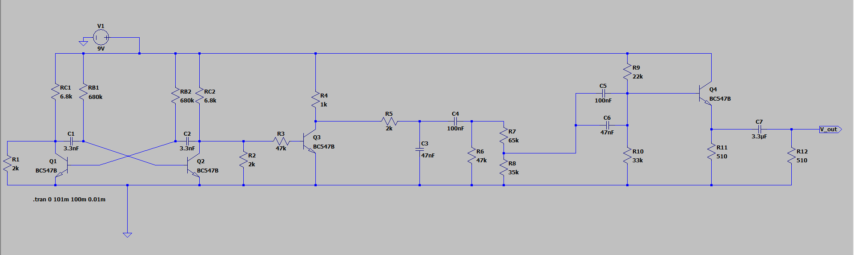

**Simulations:**

Use the FG simulation done earlier to provide Vin to your amplifier circuit. This will be a frequency *f ~ 1.17kHz* so it should sail through the 100Hz high-pass cutoff frequency of your amplifier.

Specify Vin to have a pk-pk signal of 1V, centered around 0V. i.e. Vin should swing between +0.5V and –0.5V. Measure current delivered to the load RL both as a current probe in LTSpice, and the voltage across RL which you will measure in the circuit demo

Try a few higher values of Vin pk-pk variation: 1.5V, 2V, 2.5V Do you observe a trend? Is there a reason for the circuit’s (mis)behavior?

Put your simulation output plots here:

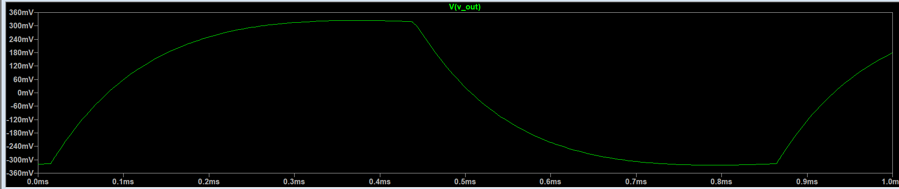

**Level 2: Circuit Demo 30**

Build the circuit as designed and simulated in Level 1.   
Use the FG as per standard design built earlier to provide Vin to your amplifier circuit..  
Before connecting Vin and poking around with the DSO, follow the usual debugging steps: check DC voltage values at each significant node of the circuit to make sure they match the simulation and your circuit is wired up correctly.   
It’s a good idea to explicitly write them down, since variations caused by component value tolerances may affect performance.

Connect Vin and probe the voltage across RL. Provide photos of your full setup with ID card in the frame as usual.

Dividing by RL allows you to re-calibrate the measured waveform VRL into a current RL

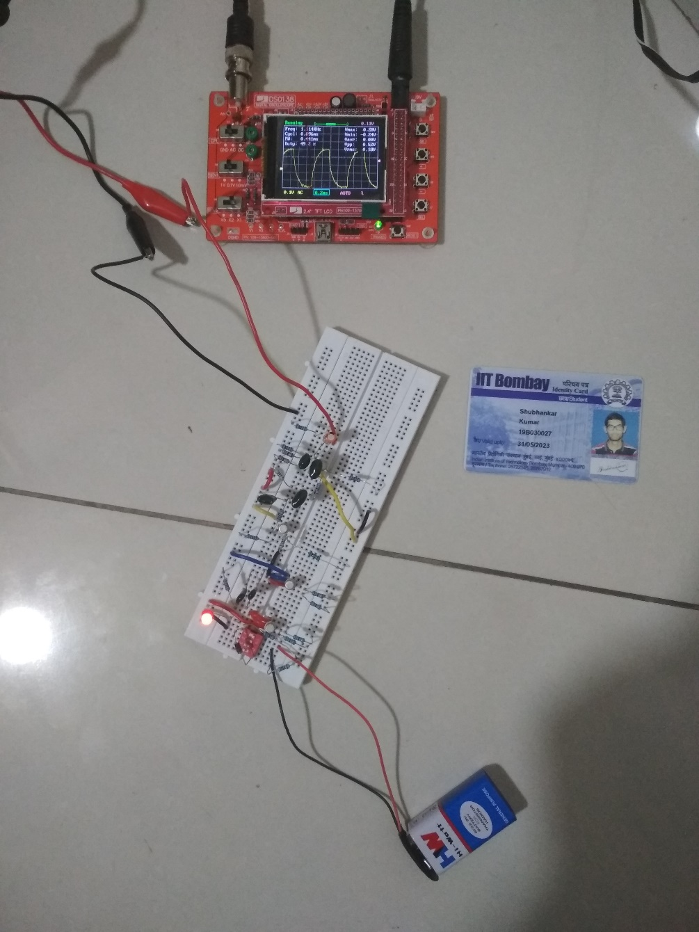

**Based on your measurements, determine the current gain $\frac{I_{L}}{I_{in}}$ actually achieved in your circuit. Is it symmetrical for both polarities of Vin?**

Current gain = (630μA)/(11μA) = 57.2

Yes, it is symmetrical for both polarities of Vin

**Level 2: Power analysis 30**

For the following analysis, it is adequate to consider the peak power consumption. RMS power formulae are applied for sinusoidal waveforms, but our test waveform is *not* a sinusoid. So you may simply take V*I products at the peak values.

1. DC power consumption at idle. Disconnect Vin and Vout: Now your amplifier is ON and idling at DC. It is ready to amplify current, but there is no input to be amplified.

Measure the power consumed by the amplifier circuit from VCC in idle   
 condition at the Q-point   
 Find a clever method to do this without disturbing the circuit operation  
 **5** Power consumed = V*I = (5.7V)*(860μA) = 4.9mW

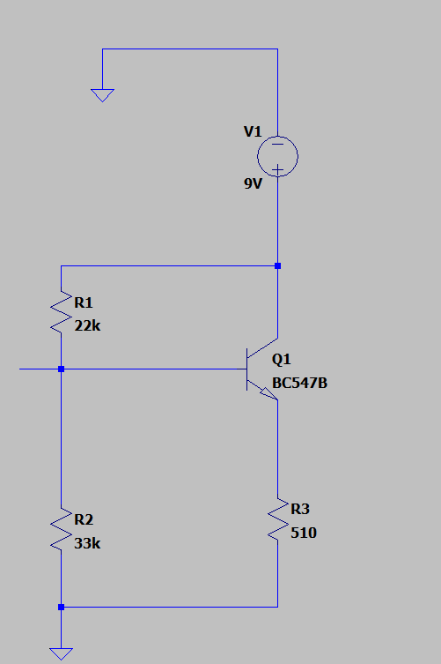

1. AC power consumption during amplification. Now apply a bipolar Vin input as earlier, and again measure the peak power consumed from VCC (a suitable modification of the method used in 1.a) might be useful)  
   Keep the power consumed by the FG circuit and the load RL as separate quantities. Power consumed by the FG can be measured independently and subtracted, *before* connecting it to the amplifier to get AC power measurement during amplification. Power delivered to the load is measured separately below.   
   *What is the power consumed by the amplifier circuit itself during AC operation?* **10**  
      
   Power consumed = (2.5V)*(200μA) = 0.5mW
2. What is the power delivered to the load? (re-verify the Level 2 result) Accordingly what is the ratio of power delivered to the load to the power consumed within the amplifier circuit itself?  
    **5**

Power delivered = V*I = (9V)*(80nA) = 0.72μW

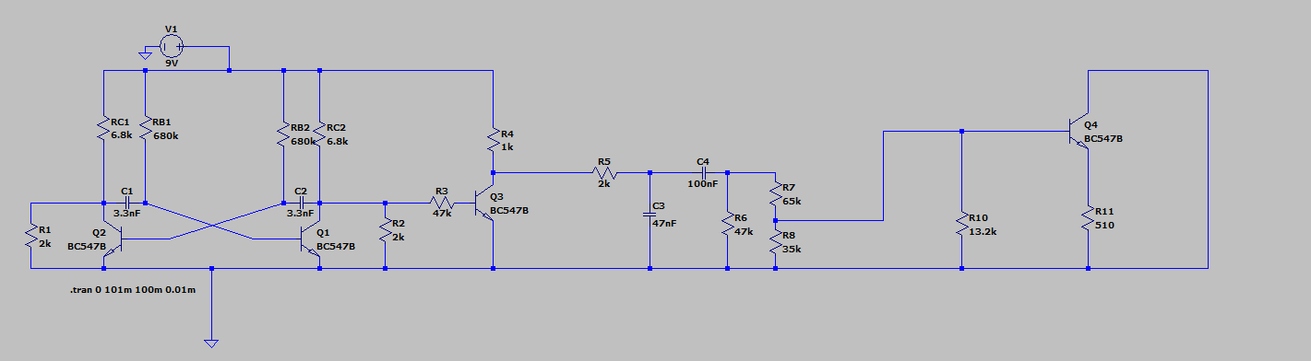

1. Provide a detailed analysis of why the current amplifier is unable to deliver the peak power specification to RL.   
   > Did you go wrong somewhere in the step-by-step calculations?  
   > Was some operation assumption violated?  
   > Is there a fundamental limitation to this circuit design that will never let it the desired peak power delivery specification? **10**

There is a fundamental limitation to the circuit design, due to which the desired peak power delivery cannot be achieved. In this case, the Voltage and currents are not constant. Therefore, we don’t get the maximum power, but rather, the RMS values are taken (which are lower than the peak values). Hence, the power delivered is less than the peak power.

**Level 3: Optimize design to reduce power consumption 20**

**[Advanced bonus question]**

**3.1** Provide a rough circuit idea along the lines of Fig 1, to solve the main problem with power dissipation in amplifier v/s poor efficiency in delivering power to the load **5**  
One can add a Zener diode connected to the base of the transistor. This would filter out some voltages and hence, the power consumption by the transistor can be controlled accordingly.  
**3.2** Fill out your circuit idea of (3.1) as a full-fledged LTSpice simulation. Use the same design parameters as Level 1. **5**

Insert your circuit design image and the LTSpice simulation results here.

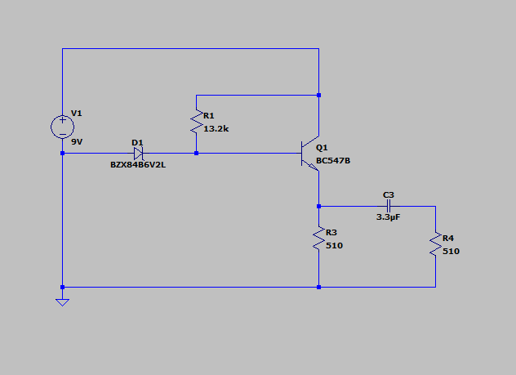

**3.3** Build a working circuit as per your full design of (3.2) and demonstrate that it achieves close to the desired power delivery to the load **10**  
As usual, provide a photo of your working circuit with your ID card and the measured DSO waveforms highlighting what is better about your Level 3 design